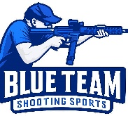
Blue Team Shooting Sports A.S.S.S. January 24th 2026

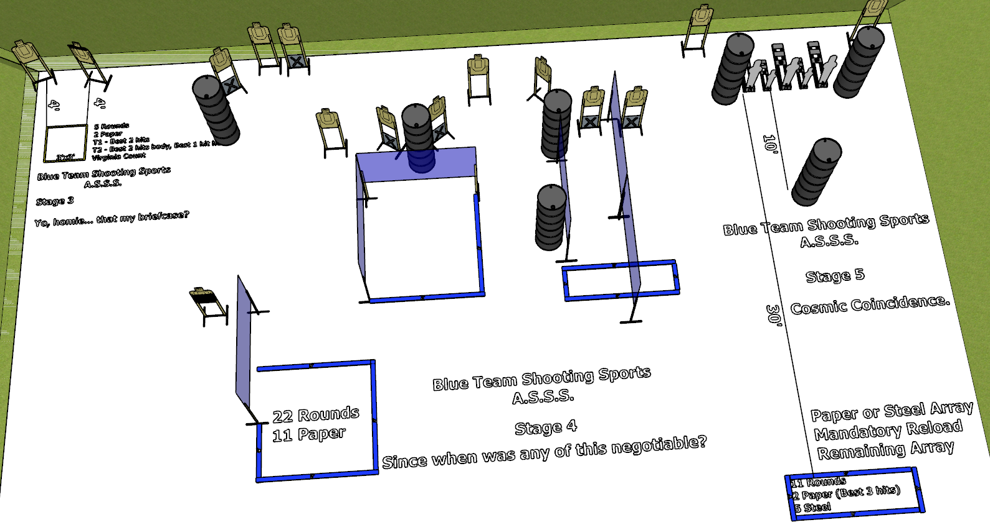

Written Stage Briefings:

Stage 3 - Yo, homie... that my briefcase? is a 5 round, 25 point, Virginia Count course. There are 2 cardboard targets.
(T3 is the headbox on T2)
Start position Both feet inside the shooting box.
Handgun: Loaded and holstered, wrists above respective shoulders.
PCC: Loaded, stock touching belt, strong hand wrist above shoulder.
On the audible start signal, in this specific order, engage T1 and T2 (body) with 2 rounds only and T2 (head) with 1 round only from within the shooting area.

Stage 4 - Since when was any of this negotiable? is a 22 round, 110 point, Comstock course. There are 11 cardboard targets. The best 2 hits per cardboard target will be scored.
Start position Anywhere
Handgun: Loaded and holstered, wrists below belt
PCC: Loaded, stock touching belt
On the audible start signal, engage targets from within the shooting area.

Stage 5 - Cosmic Coincidence. is a 11 round, 55 point, Comstock course. There are 2 cardboard targets and 5 steel targets. The best 3 hits per cardboard target will be scored.
Start position Anywhere
Handgun: Loaded and holstered, wrists below belt
PCC: Loaded, stock touching belt
On the audible start signal, engage either the cardboard targets or the steel targets then make a mandatory reload and engage the remaining targets.

